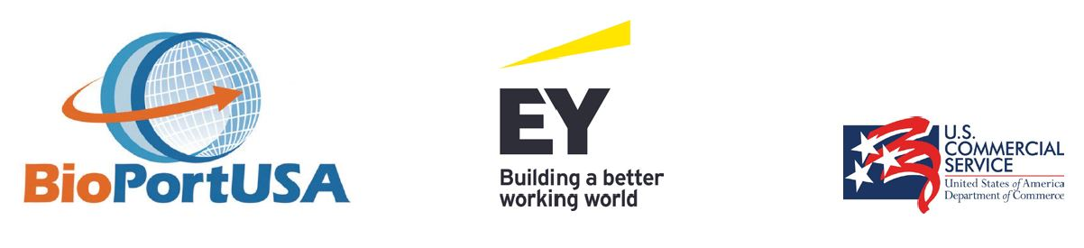

DEMYSTIFYING U.S. MARKET ENTRY
November 17 / 16:00 – 19:00

Registration Form
Email to: Sabine.Winkels@trade.gov
Or fax to: +49-211.737.767.67

Company Information
Name

Address

Country

Participant Information
Name

Title

Email

Phone

